Each and every significant dream initiates with a dreamer. Be sure about one thing, you always have the potential, strength, passion, hard working approach, patience, objectives, initiatives, to reach for the stuff that changes the world. Dreams convert into reality through imagination, which takes positive approach, sweat, determination and lots of restless hardworking, sometimes sleepless nights also and not only simply through magic’s. Your life is only worth, if you live the life of your dreams, and the beauty of your dreams, leads to a great future.
A person who is good in terms of both health and wealth, they can fulfil their dream very easily. But what about certain groups in a society which are physically disable?
Disability obviously doesn’t mean that they don’t have any right to see the dreams or pursue their dreams. Day by day our nation is progressing in each and every aspect since we became independent. We are getting luxurious houses with almost every facility, education, healthcare, and lot of employment opportunities, living in smart cities. We are living a life as we are celebrating it, but what about the certain class of people which are living in our society , for whom , if we wish can take responsibility and more precise should indulge them to take responsibility of their own.
So can we dream to build a society for us, where every individual (person with disability or a person without disability) gets the equal treatment in terms of everything i.e. education, jobs, respect, rights, living, dignity, marriage etc.
First intiative we can take is, to commit, to treat the humans with disabilities equally as just like individuals in the rest of the society, with the attributes of respect and dignity, and access to rights which are available to common individuals.
By dreaming only, the things do not fall at its right place, isn’t did? The commitment requires the dedication and collective efforts of the government, NGO’s, individuals, corporate officers and most importantly the person with disabilities, because if the individual is not ready to dream and live a life at fullest , you cannot do anything without his/her choice. So our first responsibility initiates from here, we should make them feel as just like the person without disability, and treat them equally with respect and dignity, and take care of them in small things, for example help them in climb the stairs or cross the road, buy for them stuff, for which it is required to wait in queue etc.
So the Journey first of all should begin from the childhood. We can help them from childhood. Individual’s childhood indulges three parts, personal life, academic life and social life.
Starting with personal life disable persons should never have the feeling of unloved or they can felt alone or lost or excluded from the family. They should grow up like an ordinary child which must contains the blessings, love and support from the family first. Moving on to academic life they must have caring and loving friends and supportive and co-operative teachers. Teachers should teach them as they don’t have any disability and disciplined them as just like ordinary students. And yes off course the children’s without disabilities should taught to take care of children’s with disability by taking care in every small things and not to make fun of them or exclude them from group, or make them alone.
As they grew up, their needs increase. As because of the disabilities they are not able to do their own stuff like carrying bags, buying things, walking without support or move on stairs without support, write the things , etc and many more. In order to resolve this reliance on nearby persons and friends should increase. For that our society needs to be prepared for helping in small terms such as one can either buy a food or book and another one can pick the bags or they just have to care when they are crossing roads or climbing the stairs.
I know it’s not an easy task. The problems persist first of all in premises itself. Disable persons may be living in flat residing at third or tenth floor. At that time persons residing nearby should help them to climb the stairs or access them with the resource they need. it’s also possible that some stairs or steps may not have handrails also, in that case family members or friends should help them, because wheel chair cannot be moved on stairs, for that you compulsory need stick, if lift or elevators are somehow not working.
You see, you cannot do anything in terms of infrastructure, for a small group of persons which are disable, but you can give one important thing that is assistance or I can say simply take care of what they need. Assistance and some sort of acceptance of a disable, individual’s can lead them to believe that they are not a distinguishable from anyone else.
Just as physical accessibility is important, society inclusion is crucial. Because it’s only that inclusion which builds’s confidence and generates sense of self-worth. This kind of incorporation gives them equal access to opportunities as their peers, helps them to become whom they want to and fulfil their dreams with passion and allows them to contribute back to the society.
Concluding childhood means they should grew up like an ordinary child as if they are without any disability. Family members, friends, relatives, teachers, neighbours, society should accept them and treat like them as they are the persons without disabilities, by making them capable to manage somehow all the things, and things which they couldn’t do nearby persons should do for them making them confident, self dependent and strong.

Awareness
Awareness about disability issues should be increased over the passing years and individuals should become aware, conscious and attentive to the necessity of individuals with disabilities.
Mission should be carried out by governments, resident’s ,individuals to generate plans for making a fair and inclusive society, where every individual has a dignified and respectful place and the opportunity to fulfil his or her dreams and ambitions.
To be truly and fairly inclusive, society first needs to acknowledge and respect the inherent dignity and worth of each and every citizen. We should understand and acknowledge that they are born with different capabilities and with different limitations. We should nurture each citizen’s capability with reasonable accommodation and mitigation of limitation, so that each of us can realise his or her potential and play a part in enriching and acknowledging the lives of others. We should treat persons with disabilities with respect as fellow human beings.
Some of the individuals with disabilities are willing to and capable of shouldering responsibilities and ready to make sacrifices for those whom they love.

Building Attitude in Disable’s:- Never say die
Apart from being perceived as a burden, persons with disabilities are frequently considered as weak and needy, whether financially, emotionally or psychologically. Yet, in the course of our work, we have met many who are determined and are pillars of strength to those around them.
Individuals with disability became almost completely dependent for his or her routine living tasks. But he or she should maintain a high spirit to encourage his or her loved ones and friends so that they would have the strength to face and tackle problems in their own lives. He or she must challenge himself or herself to be engaged with new skills, and to seek opportunities to grow and empower him or her to become a better and responsible person.
Each and every individual possess different capabilities and constraints. Whether or not the constraints are physical, intellectual, emotional or psychological, or even purely circumstantial, they should learn to rise, learn to develop new skills, in their own ways, above all constraints to be an encouragement and a role model to others. But these things cannot be done alone.

Little and Simple Take Care: - Burden, Responsibility, Duty, Joy or Selfless Service?
None of us, whether with or without disabilities, can achieve much on our own. Very often, the persons closest to us play an important and immediately impactful role.

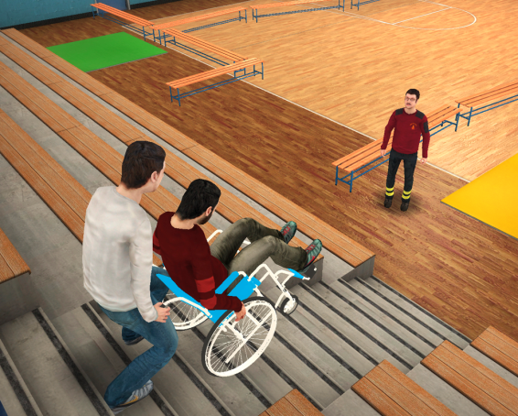

The closest persons can be friends, family members, classmates, society members etc. what they can do is motivate them in every little things, take care of their small things, help them in doing their little activities joyfully not as if you are tired or fed up. If you will do the stuff as if you are fed –up, you are realizing them at every moment that they are disabled. Hands that help unconditionally are much blessed than the lips that pray.
Building Helping Hands Group
The aim of this helping hands group should be to assist persons with disabilities to achieve their highest level of independence through quality programs and services. It is noteworthy that for as many supporters as one might identify, there are many others in the background, behind-the-scenes, without whom the positive impact on the person with disability would have been lessened. Indeed, society inclusion is not a one-man show. Unlike NGO, which is a one-way flow from donor to beneficiary, society inclusion is a contributor partnership for the betterment of society.
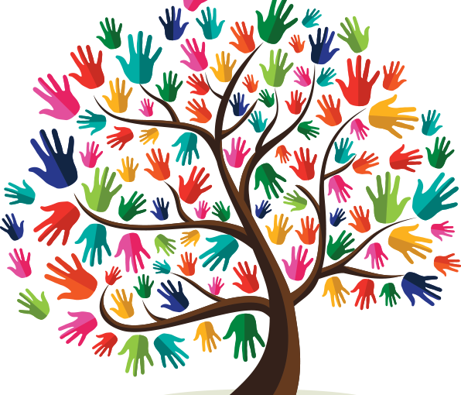
I envision the future of India as one that is truly inclusive, one in which we respect and present dignity to each individual of the society, regardless of his or her ability or limitation. It is a society that promotes social and psychological acceptance of the disabled or Divyang within our community, and provides and empowers them and their caregivers, and in which each member of our community should be able to grow and to serve one another. However, the journey towards society inclusion will be long, and unless they tackle the challenges in this journey, they will rather become obstacles in the way.
Challenges to Overcome
Individual who are disabled are often perceived as compulsory dependent on NGO. They are recognizing as lacking in capability, motivation or ambition. Those with disabilities, for example, are generally referred to as “disabled”. Such self-defeating misconceptions held by the society, and often by those who are disadvantaged themselves, constrain efforts to provide and empower the disadvantaged towards financial independence and mainstream integration.
Increasingly, there is a growing expectation that the government should do everything. While I agree that the government needs to do more, the “more“that the government does will not be sufficiently efficacious, if it works alone. Often, we assume it means the responsibility of the government, the social service sector or someone else. We forget that “collective” includes ”me”. We demand services for the community or for our own convenience, yet we resist the setting up of service provider facilities within our neighbourhoods. We demand assistance, but we forget our personal responsibility.
Altering mindsets
As we move into the future what we people call 21st century; we need to alter the mindsets of all the collaborators.
Society Mindset
The society must be aware of; individuals who are disabled are as much a part of the society as those of us who walk with high head. We should acknowledge that they are born with distinguishable capabilities and dissimilar limitations. As a society, we have to accept one another and create fair space for one another, so that to the greatest extent possible, each of us can exercise equal rights to participate in the society.
Proficient, talented, skilful, professional and compassionate staff and professionals are key to the well-being of beneficiaries, and acknowledge the principle of reasonable remuneration for such staff and professionals.
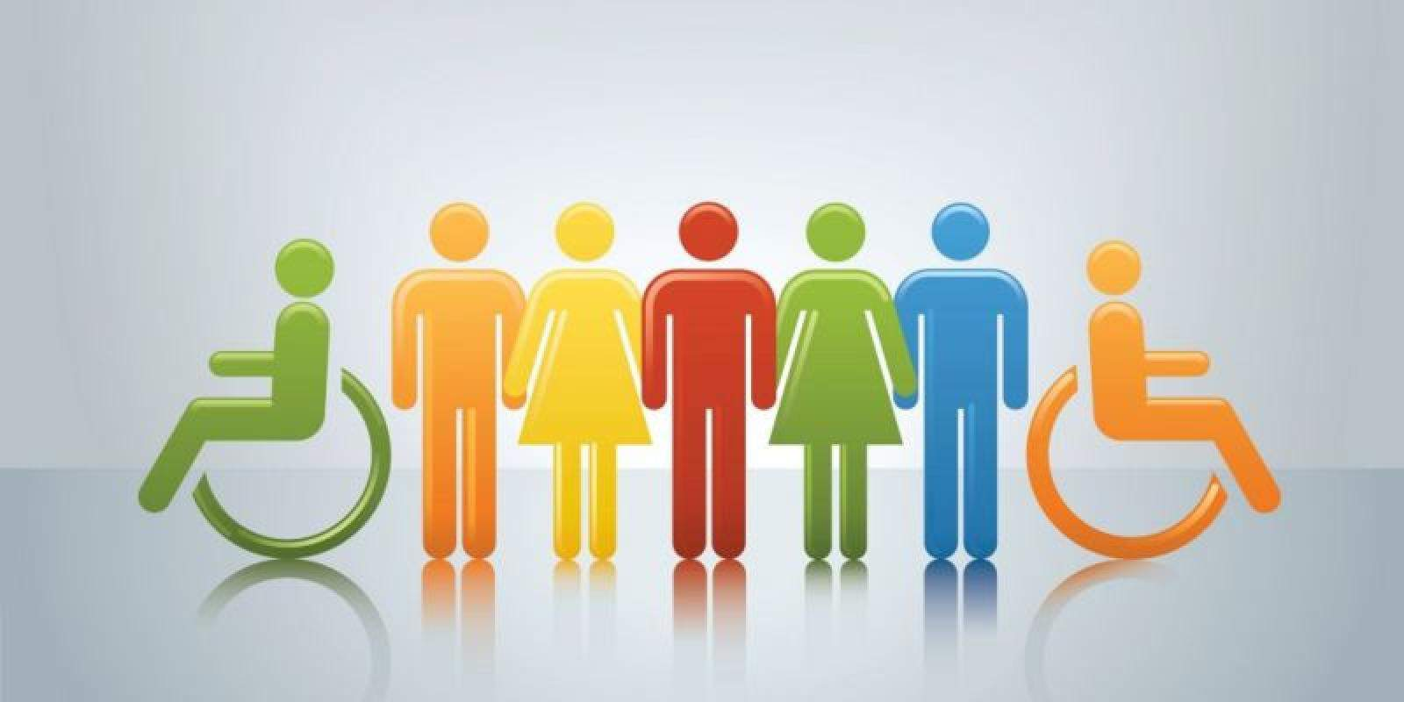

One of the harsh reality from couple of years is, those individuals , who work in the social service sector are generally paid less than their individual’s in other sectors. I, however, cannot determine of any good and fair reason why they should continue to suffer the inequity of remuneration compared to their colleagues. Reasonable remuneration is mandatory to recruit, retain and reward those who serve.
Beneficiary mindset
Individuals who are disabled should accept that they have distinguishable capabilities and different limitations, and should develop their own capabilities and challenge their limitations. They don’t always have to rely on NGO’s and government organizations. They can, if they try, to varying extent, help their own self by developing skills to deal with this kind of disabilities. They can do so by assuming responsibility for their own well-being and future and their dependents.

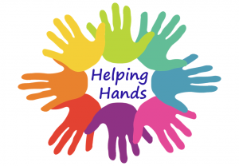
Sector mindset

In order to ensure that grantees are adequately served and taken care of, the sector needs to recruit and retain the right people. In this respect, I had earlier stated for fair remuneration. On the other hand, those who join the sector should remember that they are serving members of their community, and not just holding a job.
In addition to recruiting efficient and good people, the sector must learn to empower and provide caregivers and volunteers to supplement the services in the sector. With greater cross-community care giving, we reduce undue reliance on resources that can be better employed where professional inputs are required.

Government mindset
The government should move beyond equipping the sector with expertise and funding. It should provide the resources, expertise and framework for the sector to move towards self-sustenance in the long term.

Conclusion
Society inclusion of persons with disabilities is an important philosophy that must continue to underpin our society. Inclusion is not just about universal access to infrastructure. Inclusion is not about what society can do for an individual or a group of people. It is about how, vis-a-vis each other, we accommodate and accept what we are able and not able to do. It is about what we as members of the community can respectively and jointly contribute to it.
I believe that the altering of the various mindsets will result in the qualitative empowerment and enablement of beneficiaries and caregivers in our soceity, and in their integration into mainstream society, thereby dramatically impacting our community towards inclusion. Every citizen should have equal rights and opportunities regardless of his or her abilities or limitations. Community inclusion helps to make this happen. And I look forward to the day when we become a truly inclusive society.
“So many of our dreams at first seem impossible, then they seem improbable, and then, when we summon the will, they soon become inevitable.” – Christopher Reeve

