Inclusive Society for Divyang – My Dream
Who is disabled? Some are physically and those who thinks divyang are disable are also mentally disabled but every one of us is disabled somehow. Thanks to the person who has invented these words Specially Abled and differently abled. But I’ll just force my mind to accept Divyang as a normal person. When I was a child I have always this question have always this question that why we need to deteriorate or recuperate disables? Why can’t we see them as a normal people? Why to pity on them?
They can stand on their feet without legs also if you have eyes to see that. We are as a so called civilised people can’t even vacate a seat reserved for disables for divyang, what we are going to give them a space in our society. Earlier in our epics and history and also now in some cases, disability perceived either as punishment for misdeeds in the past life or the wrong doings of their parents. For example, Dhritrashtra a visually impaired king and the orthopedically impaired Shakuni. A prime example comes in a story from the Karthik Purnima where a disfigured elder sister of Lakshmi was rejected by Lord Vishnu, saying that there is no place for disabled people in heaven.
I usually ask myself why God has not gifted disability to me? Now I got a simple answer after contemplating that I’m not that strong soul, I have not that will power and ability to show this world which these disables have and we all know that God always put that much weight on our shoulder which we are able to lift. So these proves that they are stronger than us. And God has gifted them these special powers intentionally.
Early on I used to feel nervous and uncomfortable as I see or talk with these God’s poor, but one girl changed my perception. And I started to dream an inclusive society for Divyang. This one girl is blind but she has clear vision to become an IAS officer, and she definitely will because her spirit, her knowledge, her vision are far higher than we people with eyes but without vision. She is from Palanpur. She is an apple of her father - a small tea stall owner’s eyes. Recently on 14th July, 2018 she achieved one step success by passing her UPSC prelims in her very first trial. She was among that 2500 students who had given prelims from Gujarat and she is among 144 students who has passed prelims.
But I can’t mention her name as according to her many milestones are still left untouched from her footsteps. She has many miles to go. And I’m with her as a reader and as a friend who reads to her at her place or any time on phone in extra time. There isn’t any doubt that success will be in her hand sooner or later. I am waiting for a news headline reading “First time in the history of Gujrat, a visually challenged girl passed UPSC in her first trial.” And she has proved to this word,
“संघर्ष में आदमी अकेला होता है,
सफलता में दुनिया उसके साथ होती है।
जिस-जिस पर ये जग हँसा है,
उसीने इतिहास रचा है।”
Now coming to the thing she taught me in
Figure1 A visually challenged UPSC aspirant to whom I help
her own words, “In the eyes of people I’m blind. But God has given me a super power and he doesn’t want me to waste it on judging people by their looks, colours and clothes.” Just imagine to whom would you impress if the whole world is blind?
Don’t limit your compassion to giving a small change by opening your car window at the traffic signal to a man standing with the help of crutches or rolling on wheel-board. Do more! We’ll have to decide what’s that more.
I have a small contribution in this field. In debut I started from changing my mindset and then changing minds of my family and friends around me. Just one sentence I repeatedly saying to them is “Just stop making prejudices, go straight and talk with these people.” In my opinion I have always believed that they are having more humanity than we full one piece humans. We are all mistaken that they are angry or disappointed for what god has given them as challenge. Then who are we to feel sorry for them?
One thing I noticed is people take cheap motivation by seeing them in their way. For an example once I was waiting for my bus in bus stand at there one lady was also sitting at that time one orthopedically impaired lady entered and I looked at that another lady and from her expressions I can definitely say what she was thinking. She was thanking God that god has given her two legs and she has more ability than that disabled lady. In first instance you are saying that they are specially abled and oppositely in the corner of our mind we are approving them as underdog.
Just by saying specially abled, they’ll not become. Society needs to change. There are such people who are making change individually. But they need to be united. These all warriors are following one saying of Paulo Coelho, “We warriors of light must be prepared to have patience in difficult times and to know the universe is conspiring in our favour, even though we may not understand how.” Research also says that if the person is SA from one or more organ of the body than other active organ will work more actively than normal people.
There are number of examples of lotuses from mud. Look at an Indian blind MIT pass out and millionaire businessman – Srikant Bolla, from the great depression to world war 2 the person who guided United States – Franklin Roosevelt, we all know this acclaimed doctor whose efforts made ATMs disabled- friendly – Satendra Singh and how can we forget a renowned scientist who had nothing working physically except his mind and by connecting it with computer, he shared his physics theory to the world – Stephen Hawking. There are many physicists who have full body than also why they are not able to give that contribution in their field? These are all the heroes whose work has shined so well in this world that their disability faded like anything.
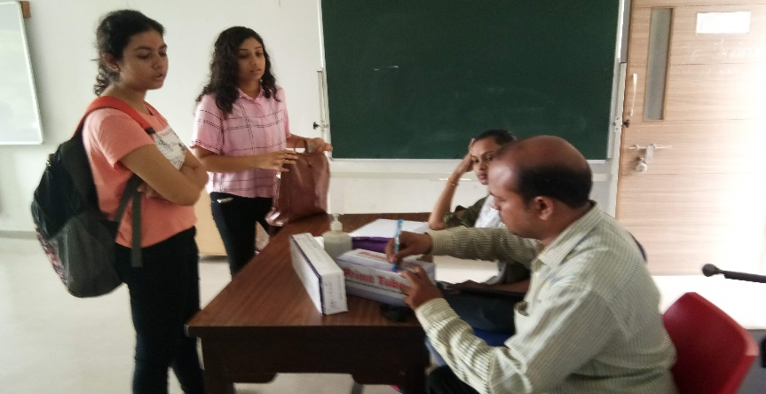
Now thalassemia is also included under the person with disability act. And in this field a lot of awareness is still needed. To whichever person I talk about thalassemia and always there is a big question mark in their mind. And in some cases they also create some prejudices towards this disease. But we as an active member of HLCC NSS unit (National Service Scheme) have taken this mission to spread thalassemia awareness. As a senior NSS volunteer every year we have organised thalassemia awareness programme. And as a part of it we have also arranged thalassemia check-up camp in association with Red cross society. For the benefit of thalassemia oppressed children we have also arranged blood donation camp with Red cross society every year. In these three years we got immense satisfaction by helping needy people.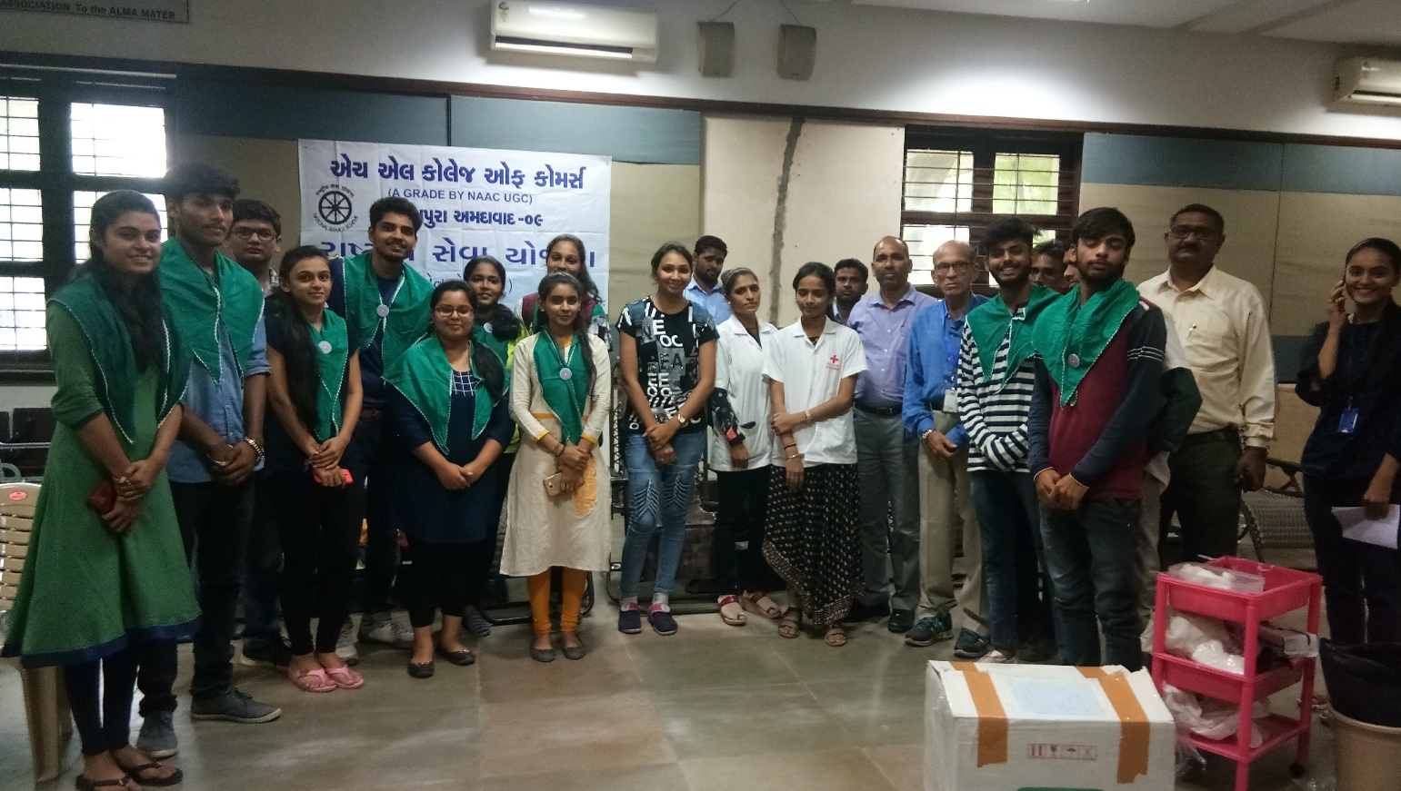
Figure 2 thalassemia check-up camp
Figure 3 Our NSS team spreading awareness
By concluding I would like to tell that we are all here on a journey free of cost. One day we all will depart. Don’t worry about seat reservation; it’s confirmed. The flight is always on time. Our good deeds will be our luggage, humanity will be our passport, love will be our visa. Make sure we do our best in journey to heaven in business class. I want our society to taste the fruit of helping people as I tasted by helping. We all do need help at every stage of life whether it’s physical or mental that’s why we are social animal. Find me one person who claims that he/she don't need help of anyone I can prove them how it's not possible. And it is truly said by Gandhiji that “The best way to find yourself is to lose yourself in the service of others.” At last I have taken an initiative to help people in tasting the fruit of helping.
Thank You.
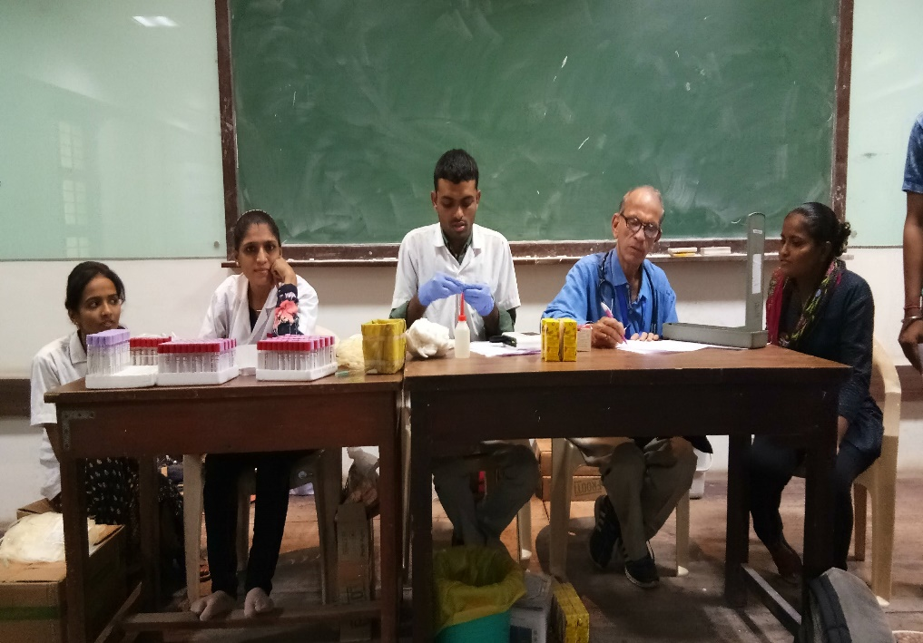
Figure 3 Blood donation Camp
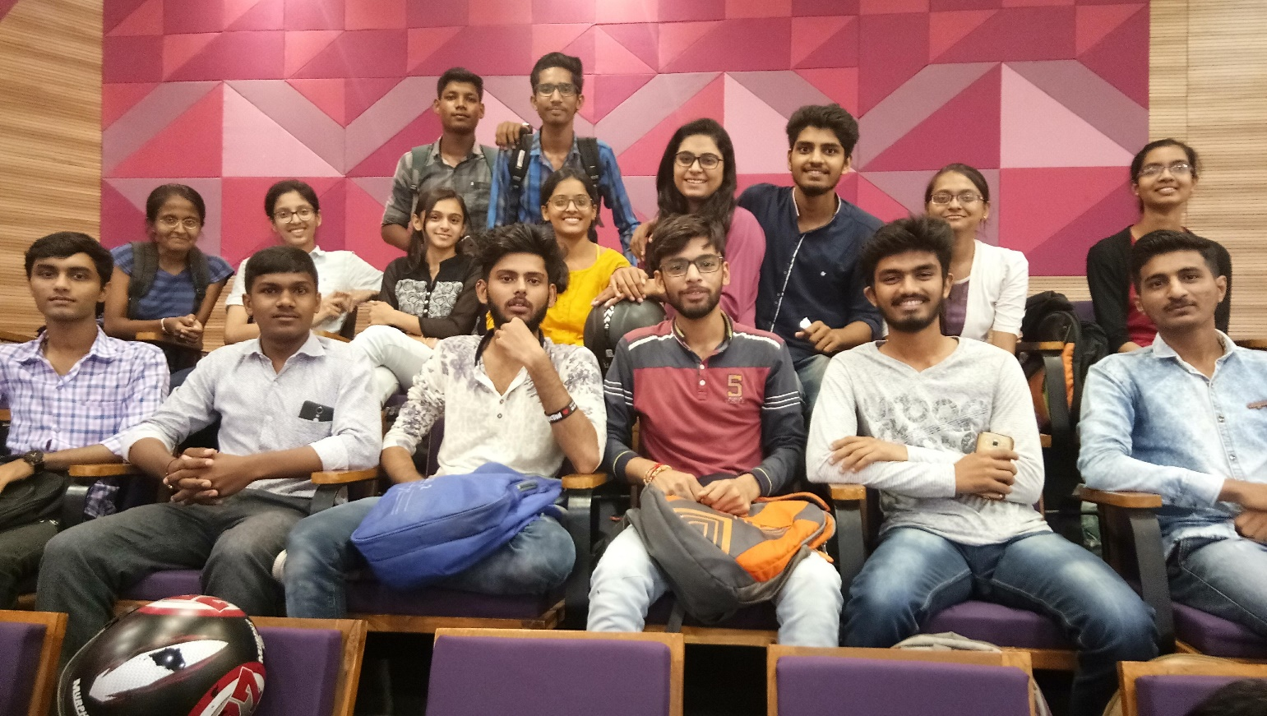
Figure 4 Volunteers first they are attending seminars to become aware to spread awareness in society

