Inclusive Society for Divyang – My Dream

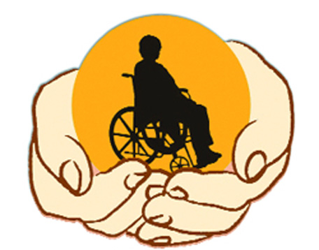

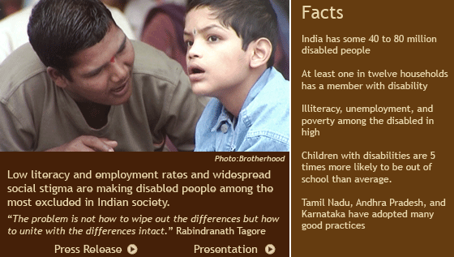
If somebody says ‘viklang’ (physically challenged person), we immediately start looking for the defect in his or her body. If we start calling them ‘Divyang’, then it immediately changes the perception, to focus on what is the special part of the body with divine powers given by God. This will create a change in the mindset of the people.”

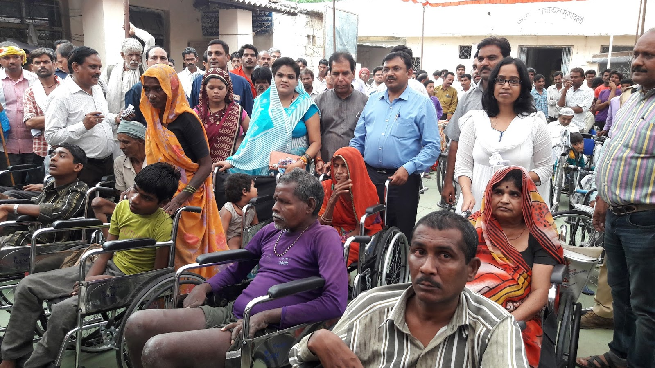 But Sometimes I was disagree with the view that disabled people should be referred to as ‘part of the divine’. Such nomenclature literally forces theistic ideas down people’s throats. What if the disabled people we’re referring to are atheists? They would probably feel disrespected by this term. Religion and God should be kept out of such matters and neutral terminology like the Hindi equivalent of ‘differently-abled people’ would probably be a better alternative. Mr. Modi should also allocate a greater portion of the Union Budget towards the actual development of infrastructure for the differently-abled so that their lives can be made more comfortable. If he wants to effect attitudinal changes towards the differently abled, he could invest more in awareness programmers in schools because most ideas and prejudices are formed in children when they are of school-going age.
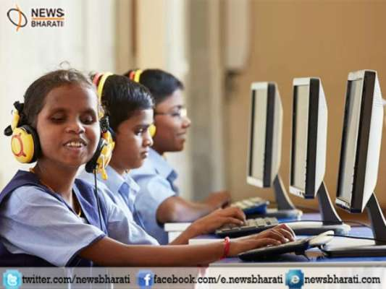
People in institutions are disempowered, isolated, and denied basic rights like education, employment and the right to live in the community as equal citizens. Lack of heating, malnutrition, inadequate clothing, unhygienic sanitation, abuse and exploitation, and little or no rehabilitative or therapeutic activities are just some of the problems reported in institutions.

Society for disABILITIES
Disabilities is an umbrella term, covering impairments, activity limitations, and participation restrictions. An impairment is a problem in body function or structure; an activity limitation is a difficulty encountered by an individual in executing a task or action; while a participation restriction is a problem experienced by an individual in involvement in life situations. Disability is thus not just health problem. It is a complex phenomenon, reflecting the interaction between features of a person’s body and features of the society in which he or she lives.
Disability is a contested concept, with different meanings in different communities.^{[3]} It may be used to refer to physical or mental attributes that some institutions, particularly medicine, view as needing to be fixed (the medical model). It may refer to limitations imposed on people by the constraints of an ableist society (the social model). Or the term may serve to refer to the identity of disabled people. Physiological functional capacity(PFC) is a related term that describes an individual's performance level. It gauges one's ability to perform the physical tasks of daily life and the ease with which these tasks are performed. PFC declines with advancing age to result in frailty, cognitive disorders or physical disorders, all of which may lead to labeling individuals as disabled.

Why are disabled actors ignored when it comes to roles like the Elephant Man?

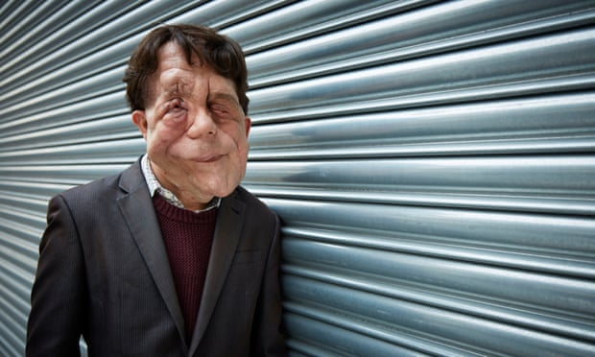

The BBC’s casting of a non-disabled actor in its remake shows how normalized exclusion is: we need to widen the talent pool
The BBC has been widely criticized over its decision to cast a non-disabled person in its remake of The Elephant Man. The role of Joseph Merrick – who had severe physical deformities – will be played by the Stranger Things actor Charlie Heaton. Notably, actor Adam Pearson – who has neurofibromatosis type 1, a condition which was once thought to affect Merrick – has said he wasn’t even given the opportunity to audition. As Pearson told LBC, it’s part of a culture of exclusion for disabled actors. “It’s a systemic problem, not only in the BBC but industry-wide.”
From Dustin Hoffman in Rain Man to Eddie Redmayne in The Theory of Everything, it’s routine for non-disabled actors to play disabled characters, often gaining critical acclaim in the process. At best, it takes work and exposure from talented disabled actors and further adds to an arts and yes, this Question is very serious for us because the when disabled people have one type of self-confidence that he/she can do something creativity towards the society so……the our society has 1st responsibility to give them better achievement chances to build there carrier her/himself also particular society of them
culture that pushes disability representation – much like race, sex and class – to the sidelines. At worst, it sees non-disabled actors mimic the characteristics of a minority group without any involvement from the community it depicts.

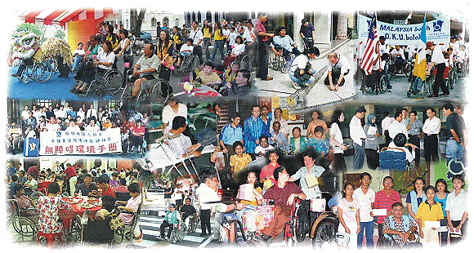

The discussion over disability's definition arose out of disability activism in the United States and the United Kingdom in the 1970s, which challenged how the medical concept of disability dominated perception and discourse about disabilities. Debates about proper terminology and their implied politics continue in disability communities and the academic field of disability studies. In some countries, the law requires that disabilities are documented by a healthcare provider in order to assess qualifications .

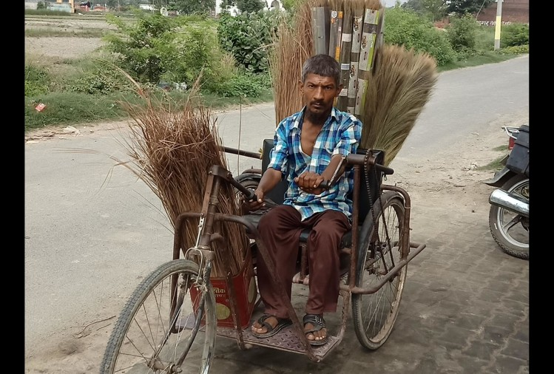
Disability is created by barriers that exist in the so-called normality narrative, in processes and structures. This not only limits opportunities but also excludes people and groups from participation. The mindset and the language we use, reflect how we look at disabilities or diversity that challenge the normality. One of the classical ways of excluding people with diversities has been to link them with some extraordinary, yet, abnormal imagery. Like defining women through relationships – like mother, daughter, goddess – a personification of sacrifice, someone with unfathomable strength to endure suffering and so on. People with disabilities being called PM Modi’s ‘Divyang’, is nothing short of reverse stereotyping, which again is excluding, as it positions people with disabilities as some special creatures with special skills, and every time it is used, it reminds me of disability rather than humanity and citizenship rights. Let’s get serious about empowerment and an inclusive society rather than inventing a new imagery of disability akin to divinity.
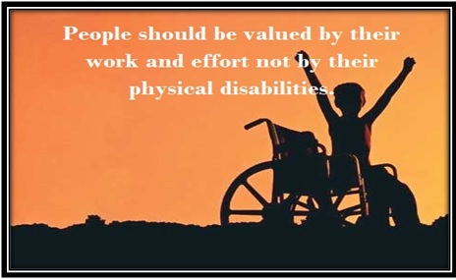
Integrating people with Disabilities: their right-Our Responsibility :-
A full understanding of disability recognizes that it has a powerful human rights dimension and is often associated with social exclusion, and increased exposure and vulnerability to poverty. Disability is a human rights issue. The World Bank (1999) report points out that one in five of the world’s poorest are disabled, for whom access to basic rights is a daily struggle. Though arising from physical or intellectual impairment, disability has social implications as well as health ones. In most countries, government services for disabled people are still small‐scale rehabilitation projects separated from the rest of the community. People with disabilities are amongst the poorest of the poor. Barriers built by disability and poverty can only be removed by the concerted and integrated effort of the government, NGOs, corporates, movie mughals and educational institutions. It is the duty of the rest of society to acknowledge the rights of the poor and the disabled. This can no longer be treated as philanthropy but is a responsibility.

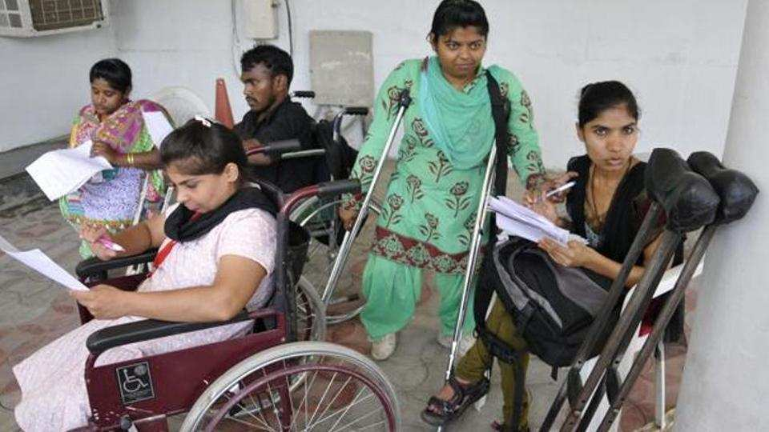

Owing to lack of knowledge, educational access and technology, disabled children were initially treated as unwanted and segregated from other children. Later their education was carried out in special schools. In recent times there has been a shift towards having children with disabilities attend the same schools as non-disabled children. The educationists now feel that each child should be allowed to learn in his own way. The concept of inclusive education has been spelt out in the Salamanca statement and the framework for action on special needs education 1994. It states that all governments have been urged to "adopt as a matter of law or policy, the principle of inclusive education, enrolling all children in regular schools unless there are compelling reasons for doing otherwise". The basic premise is that the school should meet the educational needs of all children irrespective of their disabilities or limitations.
Children with disabilities face multiple forms of discrimination which leads to their exclusion from society and school. Attitudes toward children with disabilities, as well as a lack of resources to accommodate them, compound the challenges they face in accessing education. While lack of access to school is an issue, an equal concern is the inability of the education system to ensure quality education for children with disabilities.
While the Convention on the Rights of the Child (CRC) and the Education For All framework aim to meet the learning needs of all children and youth, the Convention on the Rights of Persons with Disabilities (CRPD) recalls those obligations and further specifies that “States Parties shall take all necessary measures to ensure the full enjoyment by children with disabilities of all human rights and fundamental freedoms on an equal basis with other children”, and “ensure an inclusive education system at all levels and lifelong learning”
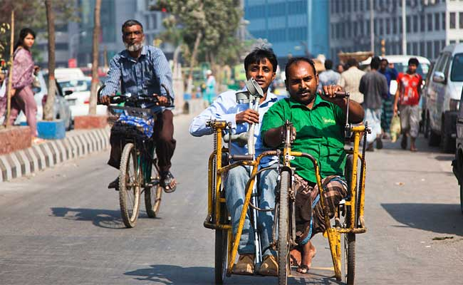
There is no clear data on the total number of children with disabilities in Lebanon or on how many children with disabilities are in school. According to Rights and Access, the government agency charged with registering persons with disabilities, there are currently 8,558 children registered with a disability aged between 5 and 14 (the age of compulsory education in Lebanon). Of these, 3,806 are in government-funded institutions, with some others spread among public and private schools. But many of those registered do not attend any type of educational facility. Furthermore, these figures are low, given that the United Nations children’s agency (UNICEF), the World Health Organization (WHO), and the World Bank estimate that at least 5 percent of children below the age of 14 have a disability. Based on this statistic, a conservative estimate is that at least 45,000 children ages 5 to 14 in Lebanon have a disability. This discrepancy raises concerns that tens of thousands of Lebanese children with disabilities are not registered as such and many of these may not have access to education.
The affirmation of the right to inclusive education is part of an international shift from a “medical model” of viewing disability to a “social model,” which recognizes disability as an interaction between individuals and their environment, with an emphasis on identifying and removing discriminatory barriers and attitudes in the environment.In Lebanon, however, authorities still seem to generally treat disability as a defect that needs to be fixed.

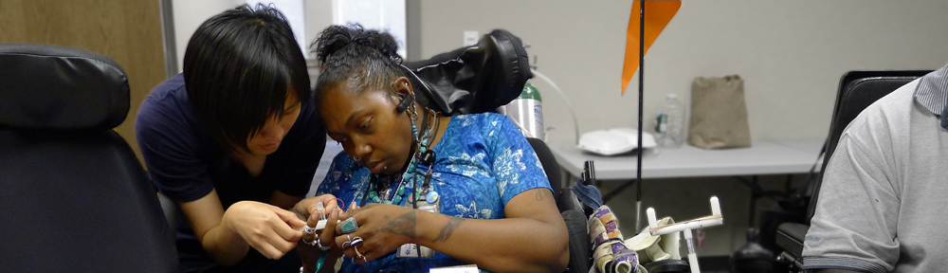
Treat a friend with a disability or illness just like you would any other friend. Your friend may want to talk about their condition; then again, your friend may not. You can let them know you care by telling them you will listen any time they feel like talking. If you’re meeting someone new, you may need to figure out how to act. You can ask the person if she wants any help and talk about the usual things you talk about with anyone new.

How to handle specific disabilities

Remember that just because people use wheelchairs, it doesn't mean they are sick. Many people who use wheelchairs are otherwise healthy and strong.
- When you're talking with a friend in a wheelchair, try to come down to his or her level — kneel down or pull up a chair.
- Don't lean on a wheelchair or touch it without asking. Don’t push it without asking either.
- It's okay to use words like "see," "hear," "walk," and "run" when you're talking with friends who have disabilities.
- It's okay to ask people who have speech problems to repeat what they said if you didn't understand the first time. You can also try repeating what you think they said and they can reply "yes" or "no."
- If you're talking with someone who has a speech problem, try to ask questions that require only short answers or a nod of the head.
- If an interpreter is helping you speak to a deaf person, talk to the deaf person, not the interpreter.
- If a deaf person is going to be reading your lips, they need to see your face. Make sure you have their attention before you start talking. Keep your hands away from your face and avoid chewing gum. Use short, simple sentences. You might try writing instead, if that’s easier.
- Don't speak loudly when talking to blind people. They hear as well as you do.
- If you need to guide a blind person, give the person your arm instead of grabbing on to hers.
- When you’re talking with a blind person, tell him when you’re leaving or he won’t know.
- Don't pet or play with service dogs without first asking the owner if it’s okay.
- Remember that just because a person has a learning disability, it doesn’t mean they’re stupid. They could be really bright and just may learn differently from you.
- When you’re talking with someone with limited intellectual abilities, be patient. Give that person time to process what you’ve said and respond. You might keep your sentences short and simple. If you are in a public area with many distractions, consider moving to a quiet or private location.
- If an adult has an intellectual disability, still treat them as an adults.
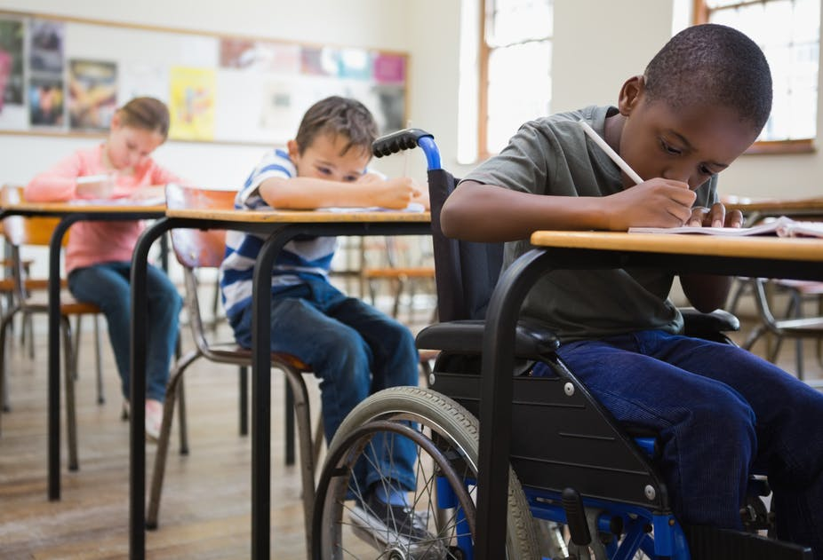
A 9-year-old girl with Down Syndrome, puts on her own backpack every day as she gets in the car to accompany her siblings to school—but despite her enthusiasm, no school has accepted her because of her disability. Human Rights Watch interviewed 33 children or their families, who said they were excluded from public school in Lebanon on account of disability, in what amounts to discrimination against them. Of these, 23 school-age children with disabilities in Beirut and its suburbs and the districts, were not enrolled in any educational program. In the cases Human Rights Watch investigated, most families said children with disabilities were excluded from public schools due to discriminatory admission policies, lack of reasonable accommodations, a shortage of sufficiently trained staff, lack of inclusive curricula (including no individualized education programs), and discriminatory fees and expenses that further marginalize children with disabilities from poor families.

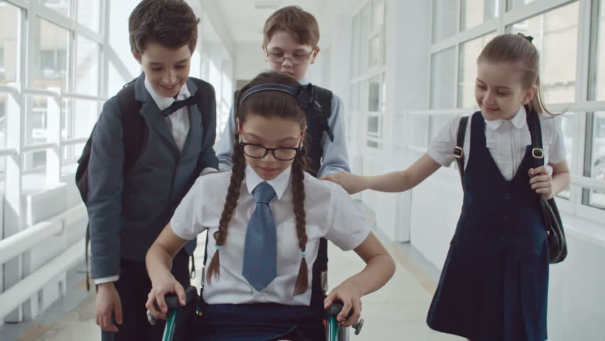

Often people who have a disability are not necessary born with it, a disability can happen to anyone at any time if they have a misfortunate accidents. Every disability is different no two disabilities are the same just as no two people are the same. Therefore it is clear that each and every individual will deal with their disability differently. Very often people who are disabled prefer to be known as a person with a disability rather than the disability label them which is more than fair as they are a person first and no one deserves to be labelled as anything else.
- If you offer assistance, wait until the offer is accepted. ...
- Speak directly to the disabled person, not through a third party. ...
- Always offer to shake hands.
- Identify yourself and others to a visually impaired person. ...
- Treat adults like adults. ...
- Don't shout.
- Don't touch, lean on, or move a wheelchair without permission

Remember, everything is relative: Some disabled writers have referred to nondisabled persons in general as TABs, for “temporarily able-bodied.” Speak directly to the disabled person, not through a third party. This tip is particularly important when addressing a hearing-impaired person and someone else is “signing” for him.
- If you offer assistance, wait until the offer is accepted. Listen for information about what form the assistance should take.
- Always offer to shake hands.
- Identify yourself and others to a visually impaired person. Always let them know when you are leaving the room.
- Treat adults like adults. Don't use a person's first name until someone asks you to. Don't pat. Don't patronize.
- Don't shout.
- Don't touch, lean on, or move a wheelchair without permission. Treat the chair as part of the person occupying it.
- Don't distract a working seeing-eye dog.
- When conversing with a person with a speech impediment, listen carefully and never pretend to understand. If in doubt, ask questions. Be patient. Don't interrupt or inject comments during pauses. Don't try to fill in a word for someone with a stutter. Don't raise your voice. Louder is not better.
- Don't fret about phrases. Speak as you would normally and don't worry about using expressions such as “running around” (to someone in a wheelchair), or “listen to that,” or “see you later.”
- It’s hard to know what it feels like to live with a disability - or to parent a child with special needs - unless you’ve walked in their shoes. Gone are the days when disabilities were seldom talked about or hidden from the public eye, and in the last ten years the blogosphere has exploded with personal stories about disability: they can make you laugh, make you cry, rally you to action or raise your awareness.
- From personal stories to education and disability activism, here are 10 of the best blogs about disability.
- 1. The Mighty -
- The Mighty’s tagline is “we face disability, disease and mental illness together” and is dedicated to sharing stories from parents and people with autism, Down syndrome, mental illness, chronic illness and other rare diseases. The Mighty has a fairly lofty goal – it wants to uplift people and to celebrate the beauty of the human sprit through storytelling. If you ever find yourself having a bad day and need a hit of inspiration, this is a great place to start.
- 2. Carly Findlay -
- Blogger and columnist Carly Findlay wants to educate people about chronic illness, disabilities, diversity and acceptance. Born with a rare skin condition called ichthyosis, her blog is informative and entertaining. Carly is no stranger to internet trolls and turned a Reddit forum mocking her appearance into an opportunity to educate people about her condition. The verdict? She won the internet with awesome.
- 3. Disability Thinking -
- Covering bigger picture issues and hot button topics, Disability Thinking bills itself as a thought-provoking website dedicated to disability life, identity, culture, commentary and politics. This site is not for the fainthearted. If you want to get stuck into some serious articles about disability issues, this is the place to be. The weekly reading list offers a wealth of links to articles and resources, and the blog also highlights current campaigns like #cripthevote.
- 4. Parker Myles -
- Kat – a mother of two - only discovered in the birthing suite that her beautiful son had Down syndrome. She has written a number of viral articles about parenting a child with special needs, and her warm style has won many fans. And if her gorgeous boy Parker looks familiar, it’s probably because he was one of the winners of the hotly-contested Bonds’ Baby Search, and is now the face of the iconic Aussie brand.
- 5. My Home Truths -
- Kirsty knows what being a special needs parent is like. Her son has albinism and high-functioning autism, and one of her daughters has Aspergers Syndrome: her blog is dedicated to raising awareness about those conditions. Kirsty is a bona fide supermum: her love for her three children and her passion for the subject matter is what makes her blog such a compelling read. My Home Truths has educated and reassured so many parents in similar situations.
- 6. Have Wheelchair Will Travel -
- Everyone loves to travel, and the ethos of this blog is that everyone deserves to have that opportunity – even people who have access issues. Have Wheelchair Will Travel is dedicated to helping people with disabilities plan and research their holidays. Lovers of travel, their goal is to facilitate fantastic adventures and unique experiences for those who require mobility assistance. Their enthusiasm for the subject matter is contagious, and will get you googling that next trip.
- 7. Living With Bob (Dysautonomia) -
- Living With Bob takes a wryly humorous approach to living with chronic illness. With sections devoted to coping with illness, going through the process of diagnosis and bigger issues around disability, it’s black humour with the intent to educate. While the tone and content might not be for everyone, Rusty has found many admirers for her forthright and honest style, and has built a loyal community around the blog. Those without wicked sense of humour need not apply.
- 8. Don’t Dis My Ability -
- Don't Dis my Ability is an Australian campaign that celebrates the diversity and ability of people with disability, and shines a spotlight on the real lives and employment journeys of people who are living with disability. It’s not a personal blog as such - and is actually run by a government agency - but it has multiple contributors with their own unique take on the subject matter. Inclusion is a recurring theme, as is accessibility.
- 9. My Disability Matters - https://mydisabilitymatters.com.au
- This comprehensive site features up to date news about disability issues, with an entire section devoted to the NDIS. With sections on lifestyle, parenting, independent living and human rights, it is essential reading for anyone in this sphere. For the best in worldwide disability news, this is an invaluable resource. It’s definitely worthy of a toolbar bookmark, and it’s one of those sites you will no doubt find yourself returning to time and time again.
- 10. The Wheelchair Mommy -
- Priscilla is a mum to three boys, and blogs about life as a wheelchair user. Her aim is to “show the world that life doesn’t have to stop just because it was turned upside down”, and her writing shines with wit and warmth. This blog is compelling because it flips the narrative – we are so used to reading about parents who have children with disabilities, but not from parents who are themselves disabled.
- These are the stories that need to be shared, and shared widely. We are so grateful for the power of the internet to connect our communities and to give voice to those who for so long have been without a voice: these blogs are a great place to start the conversation.

Disabled is the strength of the Society or Earth
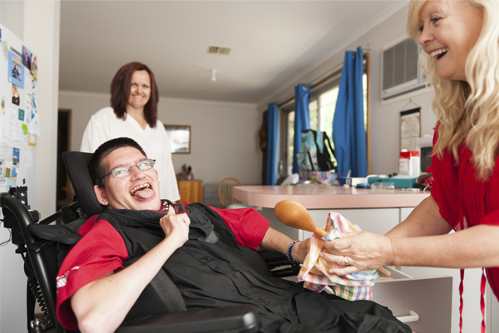

Why do mentally ill people have way higher strength reserves than able men?
At the risk of ticking off a bunch of people and getting downvoted, I'm going to change the parameters slightly to address this. I think it will answer the question posed by the end, so please bear with me for a bit.
Instead of mentally ill, substitute "high on PCP or a similar drug". (Note: This is an example, I'm not saying it always happens with any particular drug, not am I interested in debating merits of PCP. I'm simply trying to make a point.)
The reason the person coming into the ER wigged out on PCP is able to fight off numerous people trying to hold him down to get a benzodiazepine or other treatment into his bloodstream is that he has no awareness the damage he is doing to his body, whereas they are. People generally do not push their bodies to the point where muscles are ripped from bone because it hurts and the pain tells them subconsciously to back off a bit before such damage is done. If he doesn't feel the damage or his brain does not connect the pain with the actions, there is no longer a reason to stop. The drug can interrupt that system.
The same goes for a PCP crazed person that attacks the cops and doesn't stop when shot, even multiple times. They don't feel it, so they have no reason to stop until their body gives out.
In similar ways, if someone is profoundly mentally ill and enraged, or for some other reason experiencing a disconnect between body and mind, they wouldn't actually be stronger or have more stamina than 'able men' they simply burn their bodies up completely, whereas "able men" do not.
Most mentally ill people do not experience anything like thisand many actually experience the pain from their bodies more intensely than would be expected. This sort of question generalized the many kinds of mental illnesses into a single exaggerated picture.

Why do mentally ill people have way higher strength reserves than able men?

Instead of mentally ill, substitute "high on PCP or a similar drug". (Note: This is an example, I'm not saying it always happens with any particular drug, not am I interested in debating merits of PCP. I'm simply trying to make a point.)
The reason the person coming into the ER wigged out on PCP is able to fight off numerous people trying to hold him down to get a benzodiazepine or other treatment into his bloodstream is that he has no awareness the damage he is doing to his body, whereas they are. People generally do not push their bodies to the point where muscles are ripped from bone because it hurts and the pain tells them subconsciously to back off a bit before such damage is done. If he doesn't feel the damage or his brain does not connect the pain with the actions, there is no longer a reason to stop. The drug can interrupt that system.
The same goes for a PCP crazed person that attacks the cops and doesn't stop when shot, even multiple times. They don't feel it, so they have no reason to stop until their body gives out.
In similar ways, if someone is profoundly mentally ill and enraged, or for some other reason experiencing disconnect between body and mind, they wouldn't actually be stronger or have more stamina than 'able men' they simply burn their bodies up completely, whereas "able men" do not.
Most mentally ill people do not experience anything like thisand many actually experience the pain from their bodies more intensely than would be expected. This sort of question generalized the many kinds of mental illnesses into a single exaggerated picture.
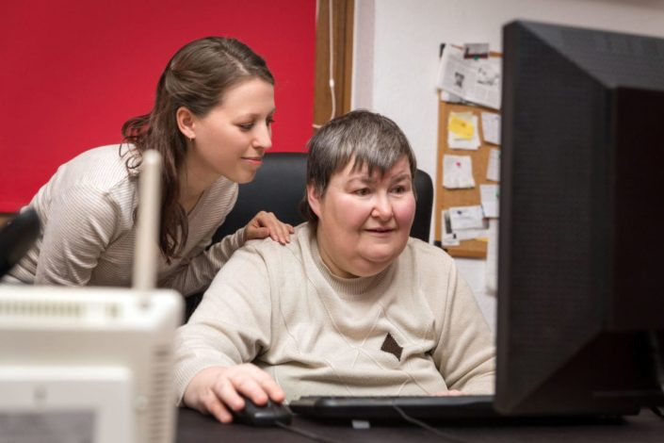
It just shows that people with normal mental capacity are holding themselves back in the interests of societal decorum.

‘Believe you can overcome physical disability by mental strength and positive mindset’
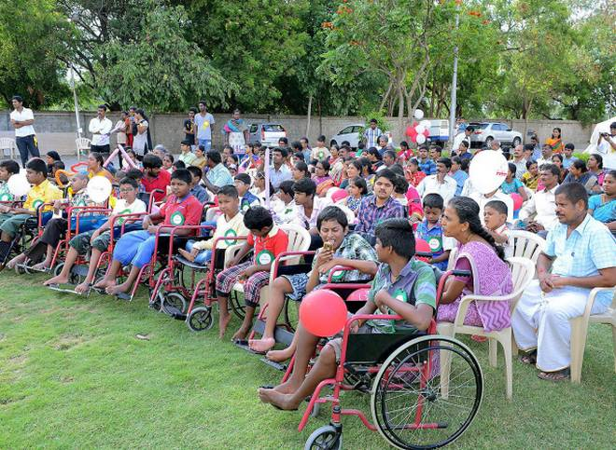
Thirty-six children affected by Duchenne Muscular Dystrophy (DMD) and Spinal Muscular Atrophy (SMA) and their parents took part in the World Duchenne Awareness Day observance here on Sunday.
The children were thrilled by fun-filled events such as toy car race organised by Molecular Diagnostics, Counselling, Care and Research Centre (MDCCRC), Coimbatore.
Magic show and balloon show were also organised to entertain the children from in and around Coimbatore who participated in the one-day event.
Parents Leelavathi of Kuniyamuthur and Radhakrishnan of Vadavalli were overjoyed to see their children happy with many such children of their age group. Children were happy and forgot pain and disability that always dominate their minds.
Managing Trustee of Swarga Foundation J. Swarnalatha delivered a motivational speech for children.
She asked them to identify their skills and strengths and work towards excellence.
She said that everyone should take care of themselves and be happy. Managing Director of Arya Vaidya Pharmacy P.R. Krishnakumarji was also present during the event.
Chairman of Kurinji Hospital K.C. Ramasami said that children affected by DMD and SMA and their parents should have a positive mindset. The doctor said that it was important that they are not weakened by negative thinking. “Believe that you can overcome physical disability by mental strength and positive mindset,” he said.

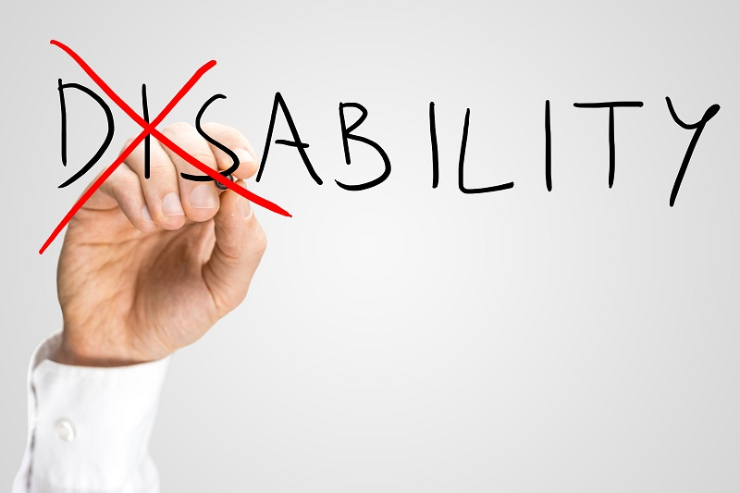
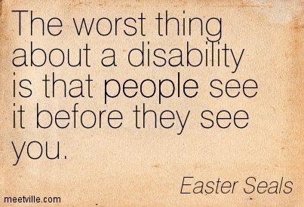
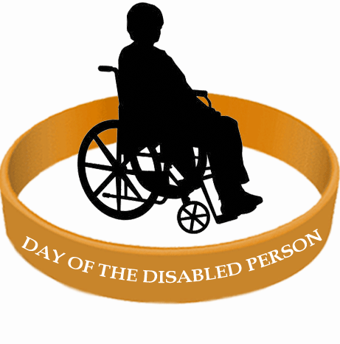
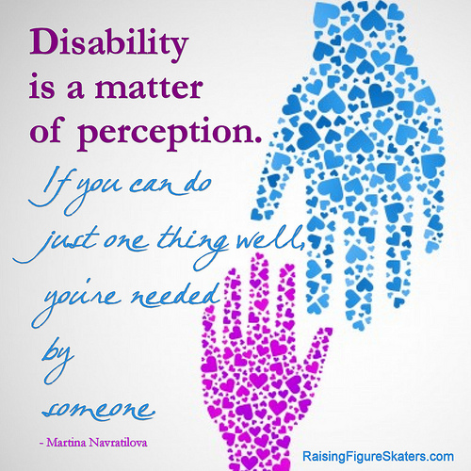

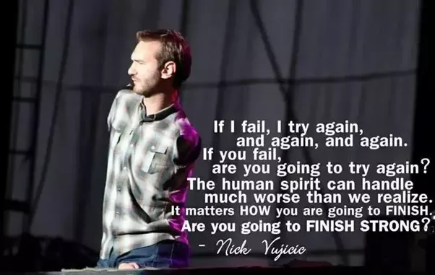

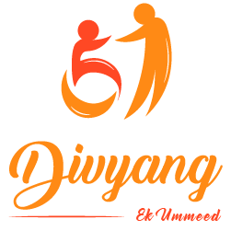
Thank you for Reading…….Hope you get some motivation or inspiration from my above article….

